# Apache Tomcat setup steps

1. Download and install Java JDK - amazon-corretto-11.0.15.9.1-windows-x64  
   Installed Java into directory: C:\Program Files\Amazon Corretto\jdk11.0.15_9
   1. URL: <https://aws.amazon.com/corretto/?filtered-posts.sort-by=item.additionalFields.createdDate&filtered-posts.sort-order=desc>

* 1. Click on Download Amazon Corretto 11. And download Windows x64 msi installer.  
     Graphical user interface, table

     Description automatically generated
  2. Amazon Corretto installation  
     Graphical user interface, text, application, Word

     Description automatically generated  
       
     Graphical user interface, text, application, email

     Description automatically generated  
       
     Graphical user interface, text, application

     Description automatically generated  
       
     Graphical user interface, text, application, email

     Description automatically generated  
       
     Graphical user interface, text, application, email

     Description automatically generated  
       
     Graphical user interface, text, application, Word, email

     Description automatically generated  
       
     Graphical user interface, text, application, email

     Description automatically generated  
       
     Graphical user interface

     Description automatically generated

1. Amazon Corretto MSI installer will set the required system environment variables.  
   If not, set system environment variables manually.  
   JAVA_HOME=C:\Program Files\Amazon Corretto\jdk11.0.15_9  
   PATH=%JAVA_HOME%\bin

1. Install Apache Tomcat - apache-tomcat-9.0.63
   1. Welcome: Select “Next” button  
      Graphical user interface, application, Word

      Description automatically generated
   2. Accept license Agreement  
      Graphical user interface, text, application, email

      Description automatically generated
   3. Select the type of install: Normal  
      Graphical user interface, text, application

      Description automatically generated
   4. Add tomcat configuration and create admin username and password (admin/M!ch!g@n)  
      Graphical user interface, application

      Description automatically generated
   5. Select the Amazon Corrotto JRE path  
      Graphical user interface, application

      Description automatically generated
   6. Choose Installation directory for Apache Tomcat and click install  
      Graphical user interface, text, application

      Description automatically generated
   7. Uncheck both checkboxes and click on finish (Note the below screenshot has one of the boxes checked).  
      Graphical user interface, application

      Description automatically generated
2. Run Apache Tomcat
   1. Open Command Prompt in Administrator mode and change directory to Tomcat “bin” directory  
      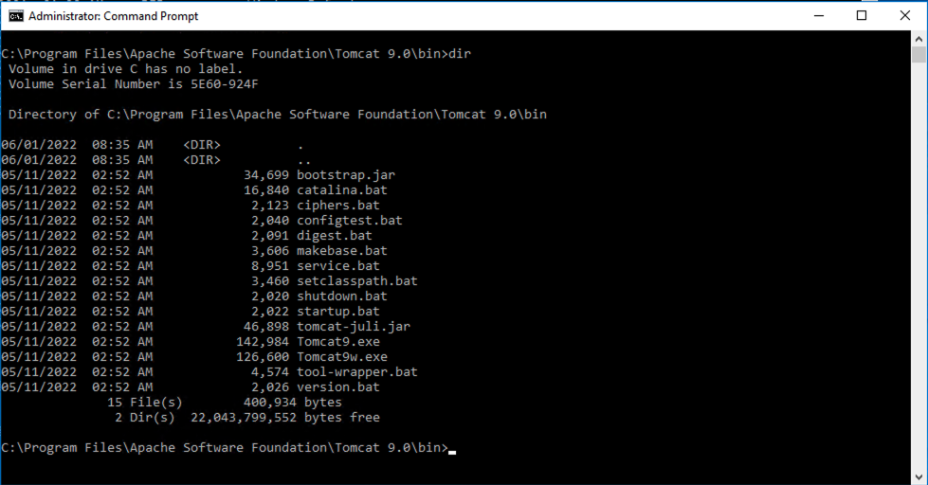
   2. Run Tomcat using the Catalina.bat script and passing “start” as parameter  
      Text

      Description automatically generated  
        
      Text

      Description automatically generated
   3. As an alternative, you can install tomcat by using service.bat in C:\Program Files\Apache Software Foundation\Tomcat 9.0\bin

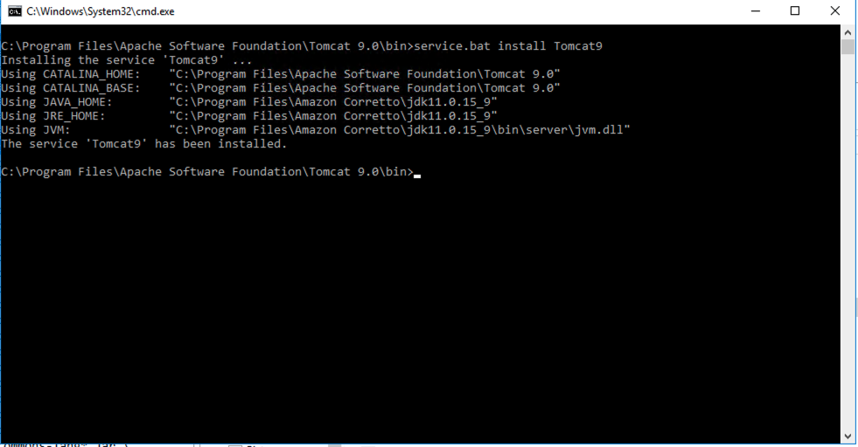

* 1. Verify in task manager, under services tab that Tomcat 9 service is installed

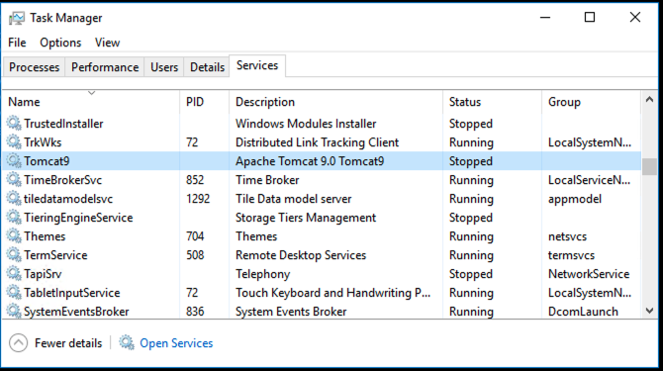

* 1. Right click of the service and start the service.

* 1. Open <http://localhost:8080/> and verify tomcat is running  
     Graphical user interface, application

     Description automatically generated
  2. To install a web application click on “Manager App” and provide admin credentials  
     Graphical user interface, text, application

     Description automatically generated
  3. Copy the war file of the application to C:\Program Files\Apache Software Foundation\Tomcat 9.0\webapps. Tomcat will automatically detect the war and deploy the application.  
     Graphical user interface, application, table

     Description automatically generated
  4. Go to the “Manager App” dashboard to view the deployed application status.  
     Graphical user interface, application

     Description automatically generated

# Tomcat Configuration

1. In C:\Program Files\Apache Software Foundation\Tomcat 9.0\conf\catalina.properties, add bcprov*.jar to tomcat.util.scan.StandardJarScanFilter.jarsToSkip=.
   1. This jar was added to JarsToSkip to resolve the EPS war deployment issue. When we tried to deploy the application the following error was thrown.
      1. Unable to complete the scan for annotations for web application [/EPS] due to a StackOverflowError. Possible root causes include a too low setting for -Xss and illegal cyclic inheritance dependencies. The class hierarchy being processed was [org.bouncycastle.asn1.ASN1EncodableVector->org.bouncycastle.asn1.DEREncodableVector->org.bouncycastle.asn1.ASN1EncodableVector]

1. The Deploy and war file to deploy results in war file not found issue. So, we are deploying webapp by deleting and adding new war into webapps folder.

1. After the paste the war file, EPS folder will be generated by Tomcat.

